**GIT ASSIGNMENTS**

PART 1

1. mkdir project_dir & cd project_dir
2. git init
3. touch index.html

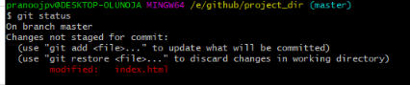

1. git add index.html
2. git commit –m “index.html committed for first time”
3. touch index.html , make changes and save

8)

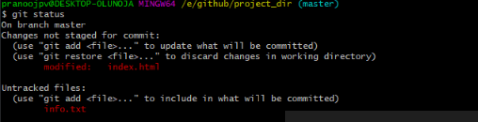

1. create a .gitignore file and add .*txt in it and save

10) git status

11) git add index.html & git commit –m “index.html committed for second time”

12) git log

13) touch index.html , make changes and save

14)

14.PNG

15,16)modify and stage: git add index.html

17)

17.PNG

18)

18.PNG

19) my_add index.html & git commit –m “index.html committed for third time”

20)

20.PNG

**GIT BRANCHING**

**Section 1-HTML**

22) mkdir Assignments

23) touch README.txt

24)git commit README.txt -m “first readme commit”

25)git branch html_assginments

26) git checkout html_assginments

28) commit first.html -m “first html”

29) vi first,html

30) first.html -m “first html commit-2”

31) git checkout master

32)change README.txt and commit: git commit README.txt -m “second readme commit”

33) git checkout html_assginments

34) vi first.html

35) commit first.html -m “first html-2”

36) git checkout master

37)

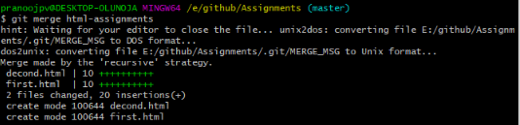

38)

last.PNG

**Section 2-CSS**

1) git branch css_assginments

2) git checkout css_assginments

3)git add first.css & git commit first.css –m “frist css file”

5) vi README.txt

6)git add README.tct and git commit README.txt -m “first readme commit”

7) git checkout master

8) vi README.txt & commit README.txt -m “second readme commit”

9) git checkout css_assginments

10)vi first.css

11) commit first.css -m “first.css commit”

12) git checkout master

13)

merge.PNG

14)

last.PNG

**Section 3-JAVASCRIPT**

1) git branch js_assginments

2) git checkout js_assginments

3,4) git commit first.js –m “frist js file”

5) vi README.txt

6)git add README.txt & commit README.txt -m “README.txt commit”

7) git checkout master

8) vi README.txt , add README.txt & commit README.txt -m “README.txt commit”

9) git checkout js_assginments

10) vi first.js

11) git add first.js & git commit first.css –m “frist js file”

12) git checkout master

13)

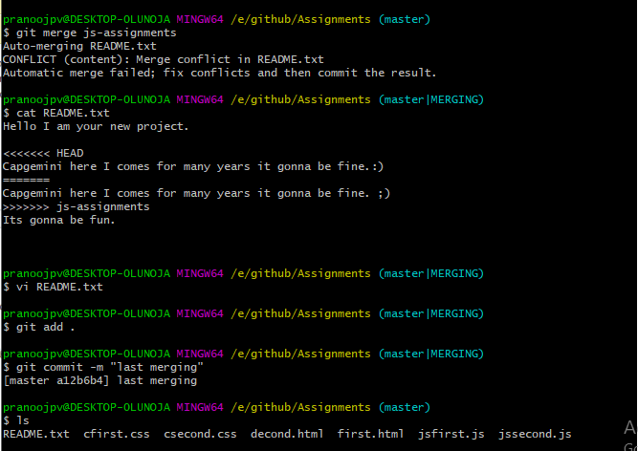

14) git branch –d “js-ssignments”

**GIT REMOTING**

**SECTION 3 AND 4**

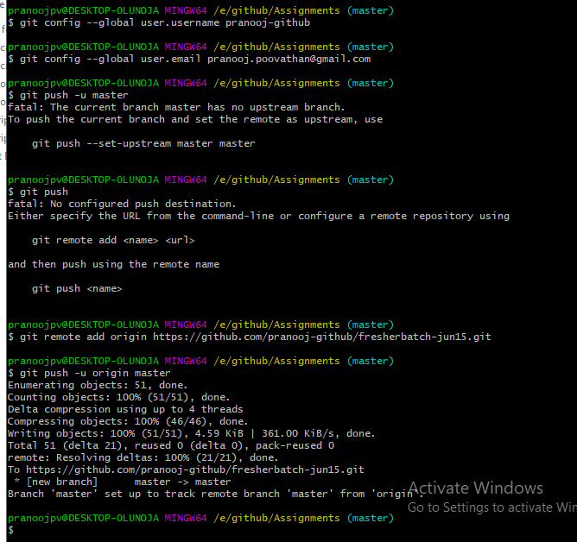

**Github repository**

